CI/CD Pipeline with Jenkins 🚀 Deploy to Kubernetes Step-by-Step

https://hub.docker.com/r/thetips4you/nodeapp
https://github.com/shazforiot/Jenkins-integration-with-kubernetes
Application repository:--
https://github.com/shazforiot/nodeapp_test.git

Deploy some pod in Kubernetes with Jenkins CI/CD pipeline very simple way. Here we use .kube/config file for authentication.
- I use kubernetes cluster in locally(kubadmin in virtualbox).
- Jenkins also install in local ubuntu server.

Install Jenkins in ubuntu server:-
Update the Debian apt repositories, install OpenJDK 21, and check the installation using the following commands:
sudo apt update
sudo apt install fontconfig openjdk-21-jre
java -version

Long Term Support release
A LTS (Long-Term Support) release is chosen every 12 weeks from the stream of regular releases as the stable release for that time period. It can be installed from the debian-stable apt repository.
sudo wget -O /etc/apt/keyrings/jenkins-keyring.asc \
https://pkg.jenkins.io/debian-stable/jenkins.io-2026.key
echo "deb [signed-by=/etc/apt/keyrings/jenkins-keyring.asc]" \
https://pkg.jenkins.io/debian-stable binary/ | sudo tee \
/etc/apt/sources.list.d/jenkins.list > /dev/null
sudo apt update
sudo apt install jenkins

https://www.youtube.com/watch?v=XE_mAhxZpwU&t=1763s
Now follow this video.

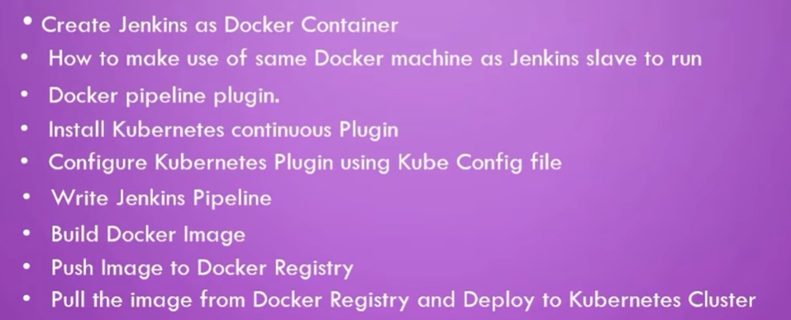

This docker hub url use:--
https://hub.docker.com/r/thetips4you/nodeapp

Running this docker container for Jenkins:--
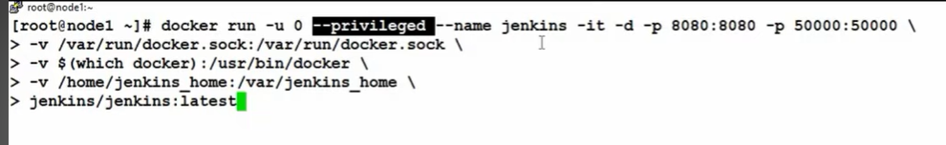
Here I use Jenkins server.
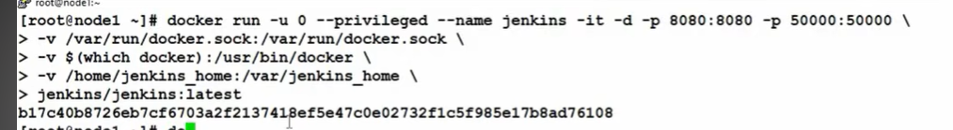

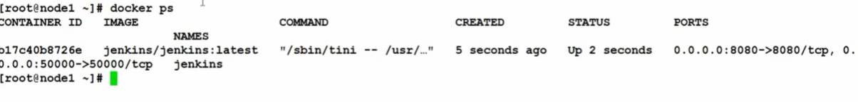

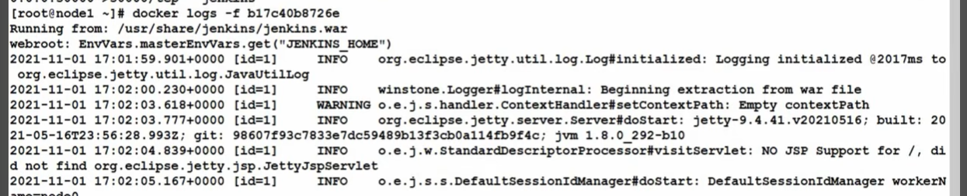


Click on pipeline syntax :---

https://github.com/anupam02us/nodeapp_test
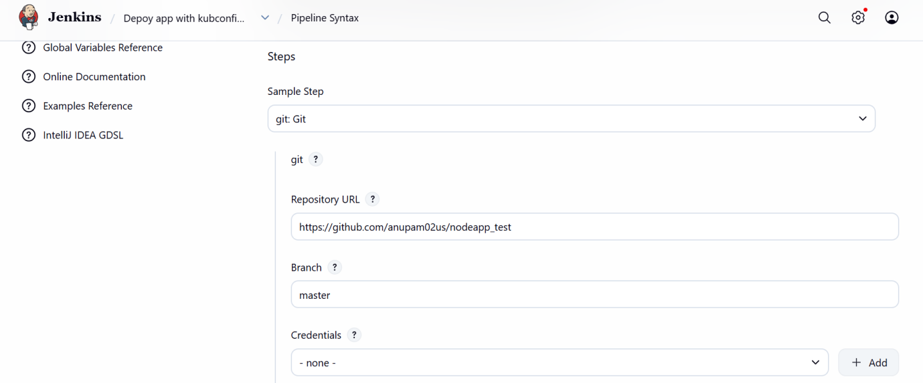
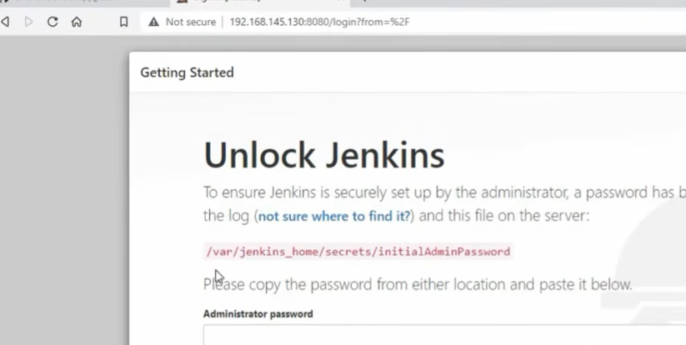

Install our plugins
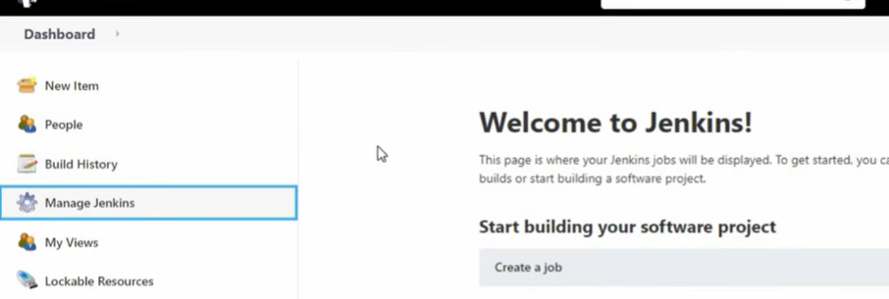

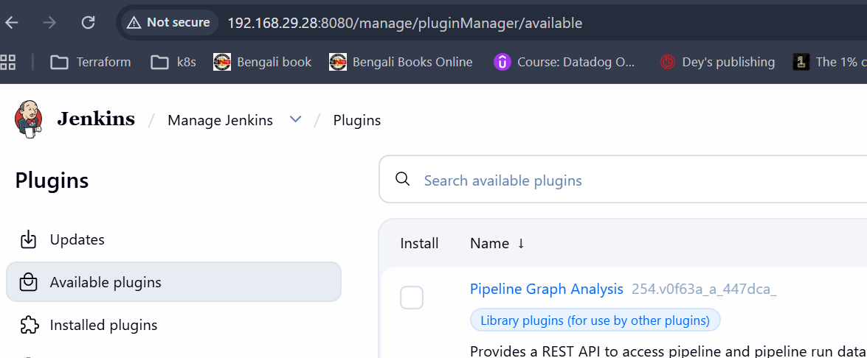

Install this plunging:---
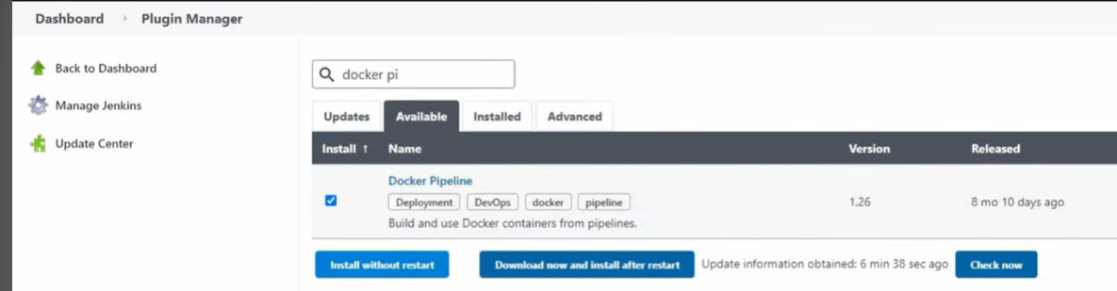

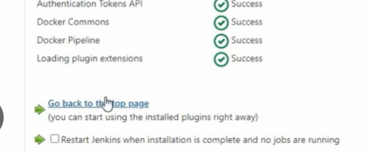

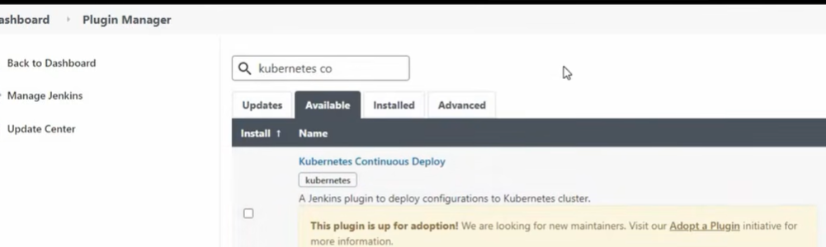
Kubernetes continuous deploy, this plugins not present leave it.

Create pipeline:---
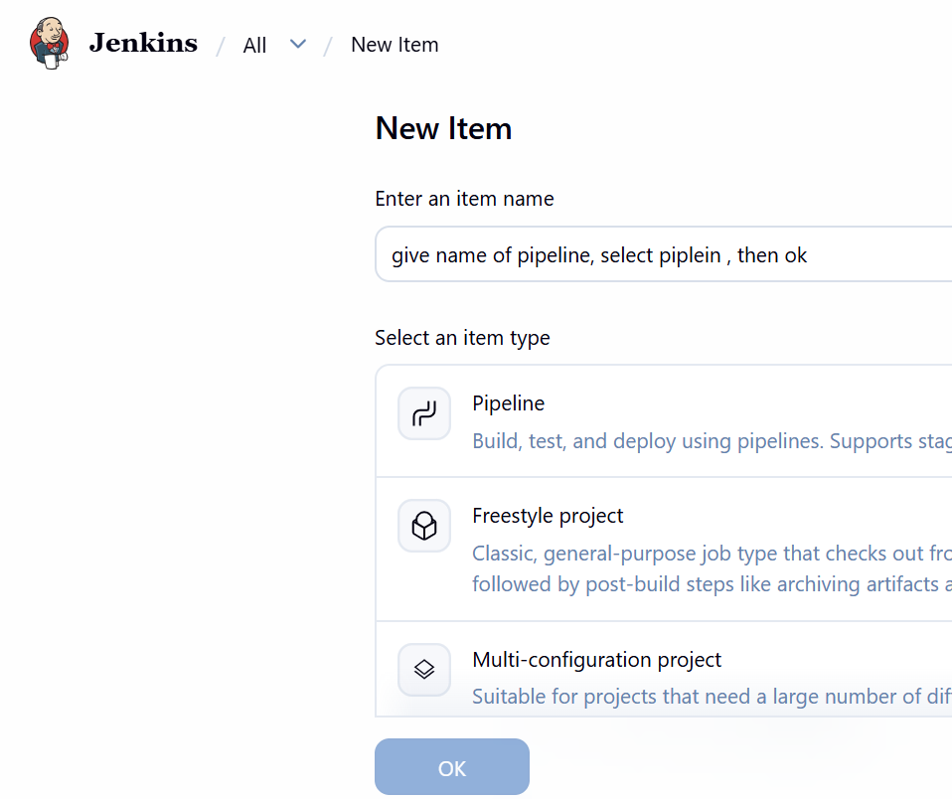

Click on pipeline syntax:---
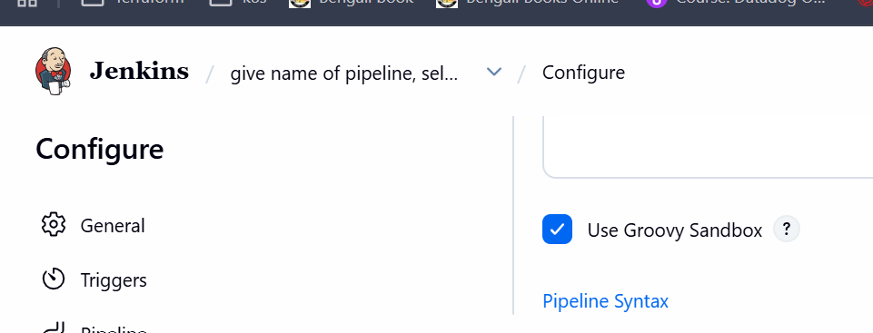

Want to configure, git check out part
stages {

stage('Checkout Source') {
steps {
git 'https://github.com/shazforiot/nodeapp_test.git'
}
}

Fork this above git repository, now add credential of git repo
Create new repo https://github.com/anupam02us/nodeapp_test

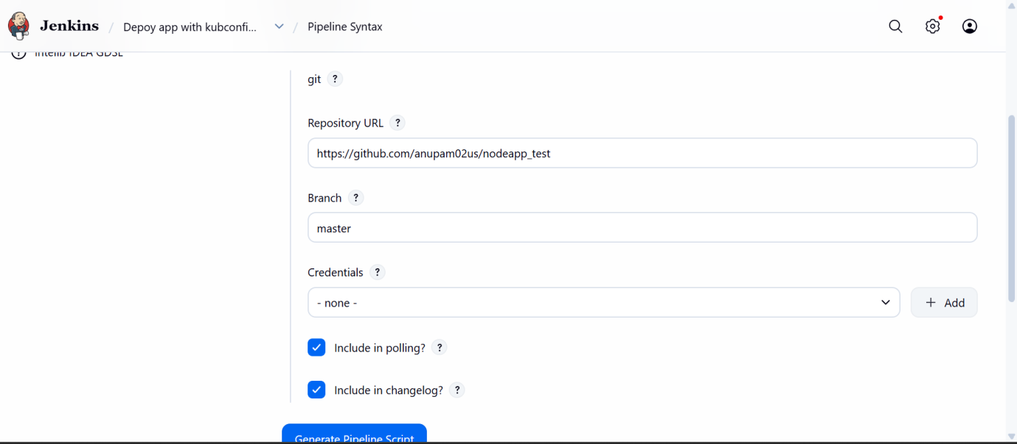
It mean below syntax is fine
stages {
stage('Checkout Source') {
steps {
git 'https://github.com/anupam02us/nodeapp_test'
}
}
}

OR you can do below, as you clone only master branch
stage('Checkout Source') {
steps {
git branch: 'master',
url: 'https://github.com/anupam02us/nodeapp_test'
}
}

Click on Add
I will build image,

Step 1: Install Docker on Jenkins Server
On Ubuntu:
sudo apt update
sudo apt install docker.io -y
sudo systemctl enable docker
sudo systemctl start docker

sudo usermod -aG docker Jenkins

Step 3: Install Required Jenkins Plugins
Install these plugins:
- Git
- Pipeline
- Docker Pipeline
- Docker
- Kubernetes (if deploying to Kubernetes)

Step 4: Configure Docker Registry Credentials
For Docker Hub:
Manage Jenkins → Credentials → Global
Add:
- Username
- Password (or Access Token)
pipeline
{
agent any

environment
{
IMAGE = "yourdockerhubuser/nodeapp"
}

stage('Build Image') {
steps {
sh 'docker build -t $IMAGE:$BUILD_NUMBER .'
}
}

I will put my dockerhub username and token

Created a token:--
https://app.docker.com/accounts/anupam2002us/settings/personal-access-tokens/copy?description=my-access-token&scope=repo%3Awrite&expiration=2026-10-27T18%3A29%3A59.000Z

To use the access token from your Docker CLI client:

1. Run
docker login -u anupam2002us

2. At the password prompt, enter the personal access token.
dckr_pat_SqYjMt2SzaIlXMMvo0Std5p2Dxg

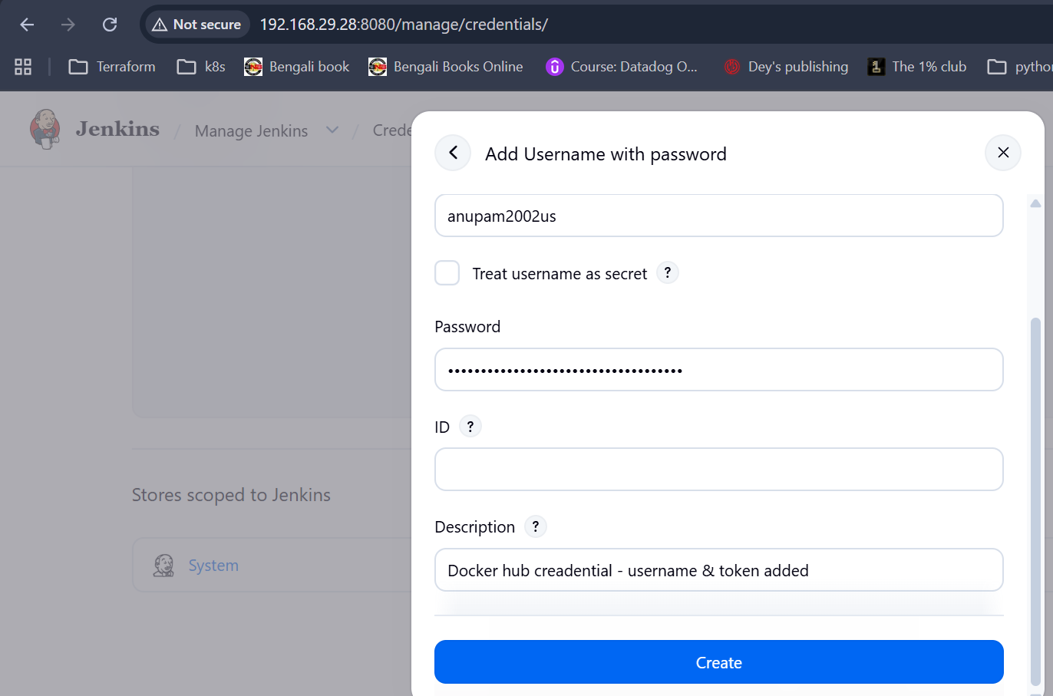

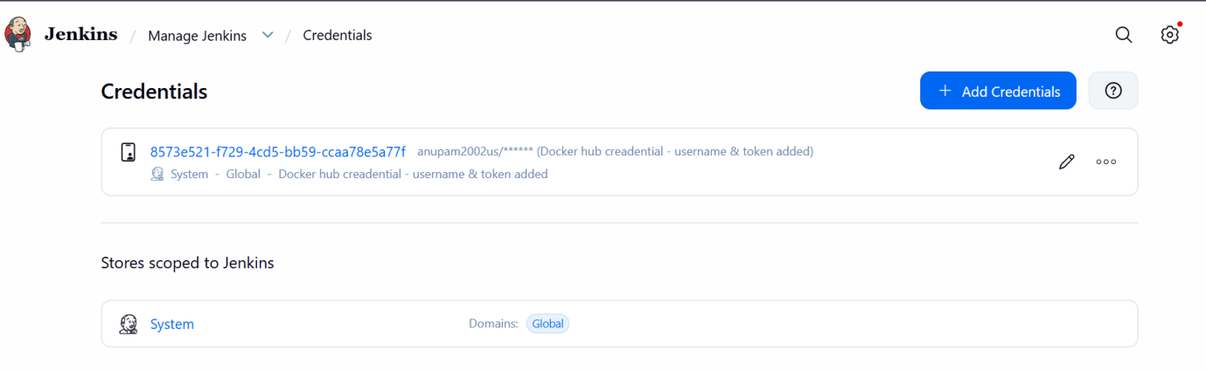

stage('Push Image') {
steps {
withCredentials([usernamePassword(
credentialsId: 'dockerhub',
usernameVariable: 'USER',
passwordVariable: 'PASS'
)]) {
sh '''
echo $PASS | docker login -u $USER --password-stdin
docker push $IMAGE:$BUILD_NUMBER
'''
}

If Jenkins Deploys to Kubernetes
Jenkins also needs:
- kubectl
- curl -LO "https://dl.k8s.io/release/$(curl -L -s https://dl.k8s.io/release/stable.txt)/bin/linux/amd64/kubectl"
- Kubernetes kubeconfig
- Permissions (RBAC/service account) to access the cluster
Verify access:
kubectl get node

Install kubeclt :---
root@anupam:~# curl -LO "https://dl.k8s.io/release/$(curl -L -s https://dl.k8s.io/release/stable.txt)/bin/linux/amd64/kubectl"
% Total % Received % Xferd Average Speed Time Time Time Current
Dload Upload Total Spent Left Speed
100 56.79M 100 56.79M 0 0 3.19M 0 00:17 00:17 3.11M

root@anupam:~# chmod +x /usr/local/bin/kubectl
root@anupam:~# ls -l /usr/local/bin/kubectl
-rwxr-xr-x 1 root root 59556002 Jul 29 09:32 /usr/local/bin/kubectl

Step 3: Add kubeconfig to Jenkins
Open Jenkins:
Dashboard
↓
Manage Jenkins
↓
Credentials
↓
System
↓
Global credentials (unrestricted)
↓
Add Credentials

Step 4: Select the credential type
Choose:
Kind:
Secret file
Upload:
~/.kube/config
or upload a copy of the file.
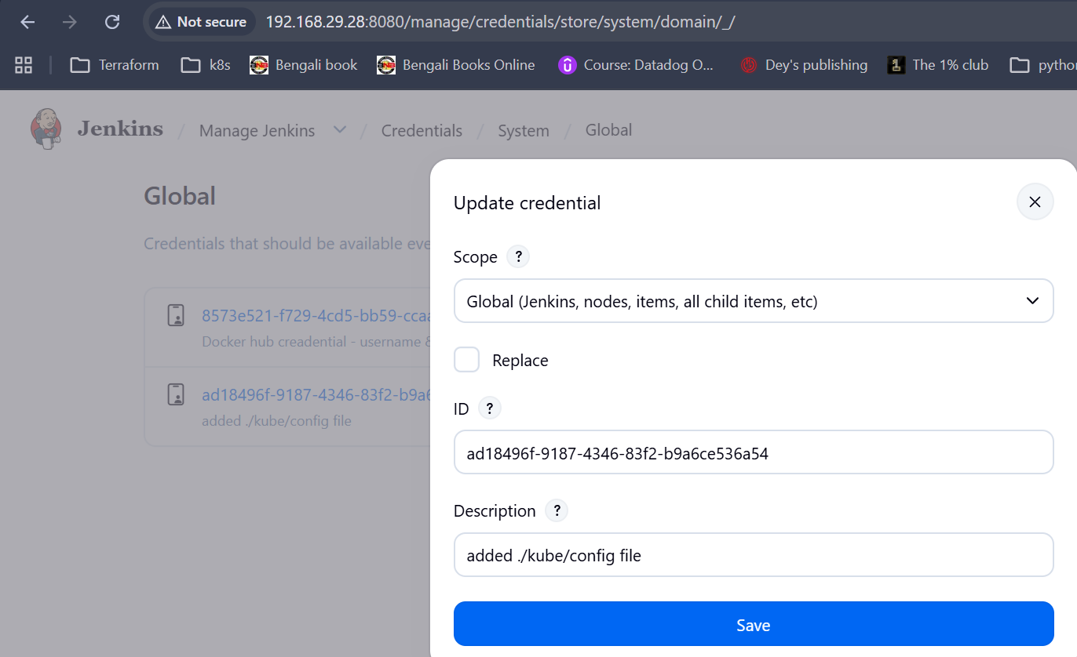
Upload .kube/config file here

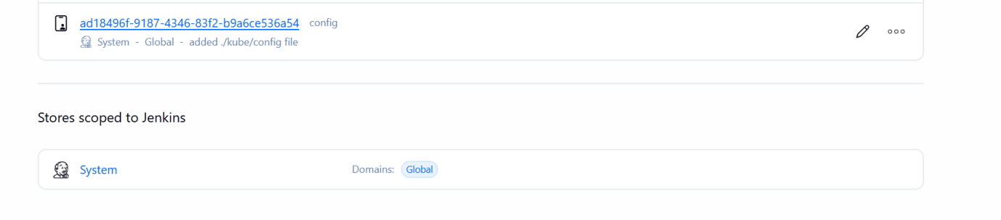

From your screenshot, I can see that you've uploaded the kubeconfig as a Secret file credential.
However, the Credential ID is currently:
ad18496f-9187-4346-83f2-b9a6ce536a54
The text config beside it is the uploaded file name, not the credential ID.

Option 1 (Recommended): Change the Credential ID
Edit the credential (click the ✏️ icon) and set:
- ID: kubernetes
- Description: Kubernetes kubeconfig
Then your pipeline can use:
withCredentials([file(credentialsId: 'kubernetes', variable: 'KUBECONFIG')]) { sh ''' kubectl get nodes kubectl apply -f deploymentservice.yml ''' }
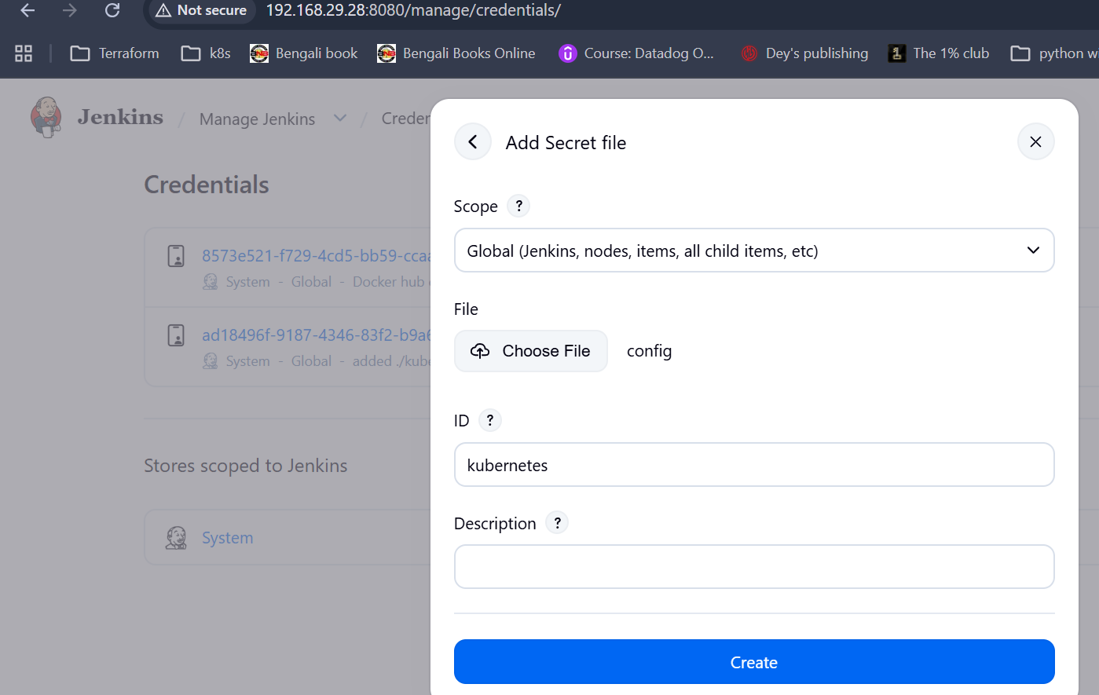
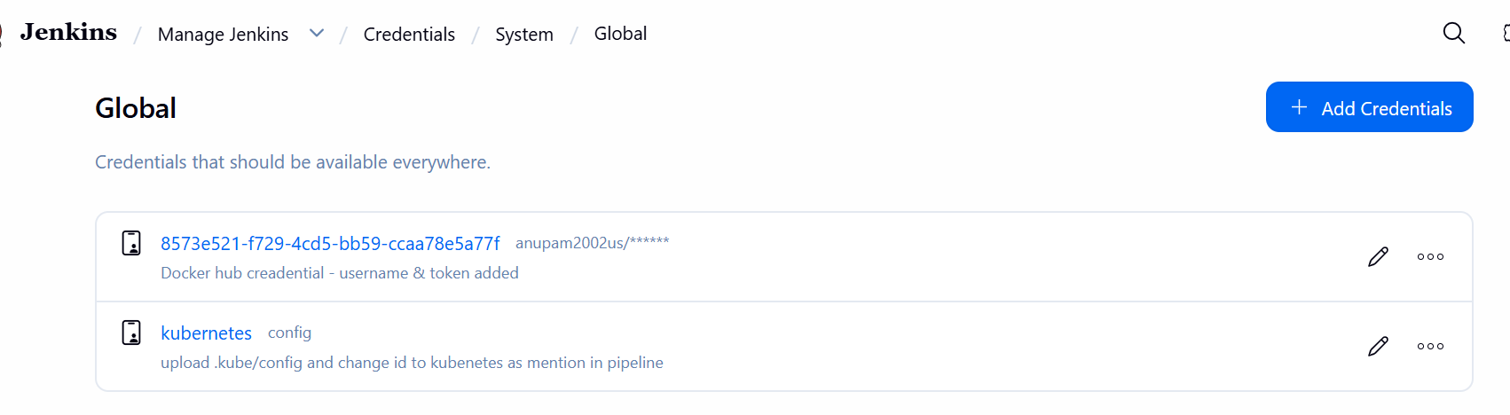

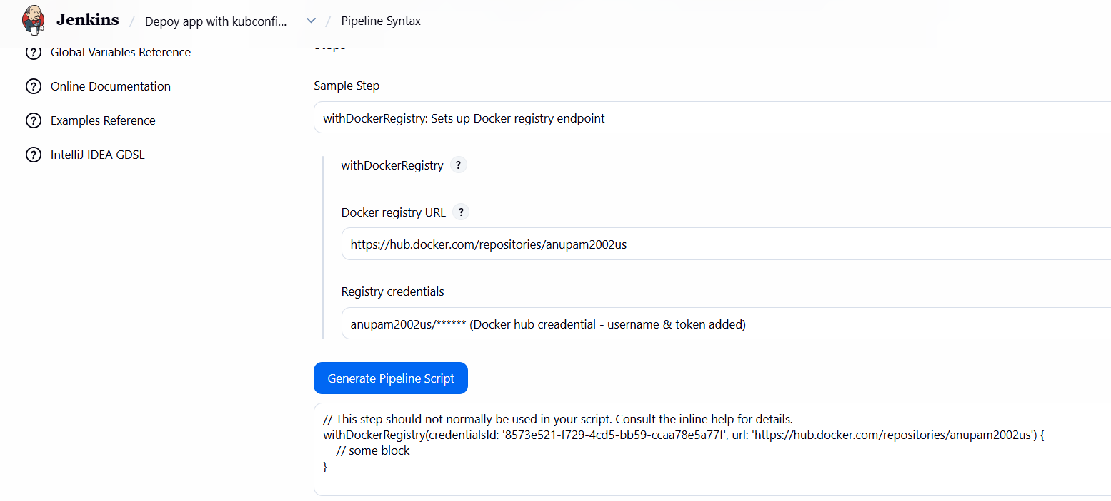

Create nodeapp repository

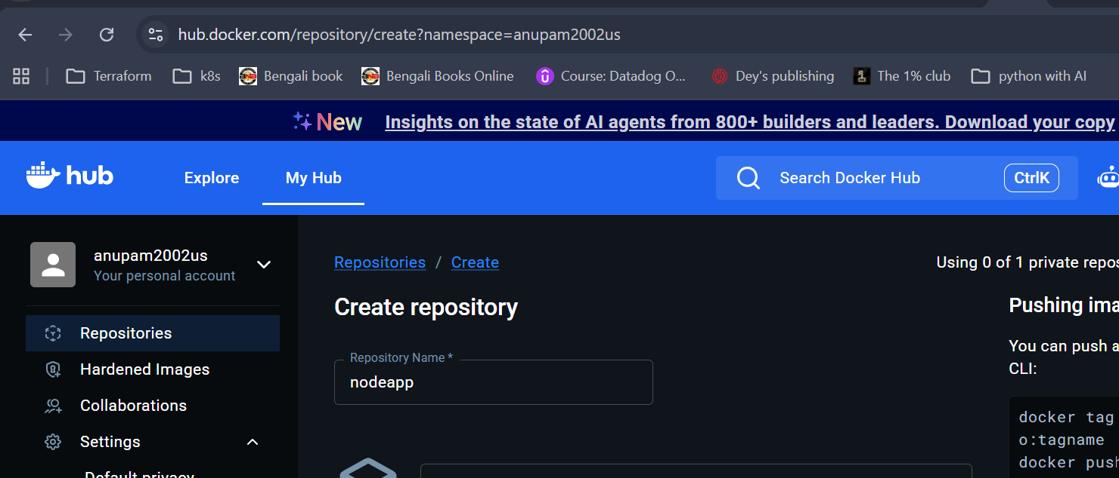

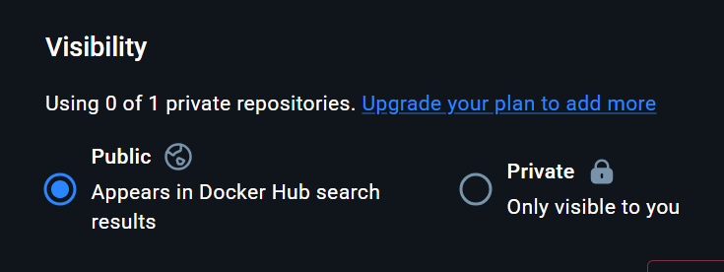

stage('Deploying App to Kubernetes') {
steps {
withCredentials([file(credentialsId: 'kubernetes', variable: 'KUBECONFIG')])

{
sh '''
export KUBECONFIG=$KUBECONFIG
kubectl apply -f deploymentservice.yml
'''
}
}
}

what is the meaning ot this

steps {
- Defines the actions that Jenkins will execute in this stage.

withCredentials([file(credentialsId: 'kubernetes', variable: 'KUBECONFIG')]) {
This is one of the most important lines.
It tells Jenkins:
"Retrieve the credential whose ID is kubernetes. This credential is stored as a Secret File (your kubeconfig file). Save the temporary file path into an environment variable named KUBECONFIG."
Suppose you uploaded this file in Jenkins:
Manage Jenkins
↓
Credentials
↓
Secret file
↓
config
with
Credential ID = kubernetes
During the pipeline, Jenkins creates a temporary copy, for example:
/tmp/jenkins123456/config
and sets:
KUBECONFIG=/tmp/jenkins123456/config
You don't have to know the exact location—Jenkins handles it for you.
Deployment not configure properly, I change into loadbalancer:

https://github.com/anupam02us/nodeapp_test/blob/master/deploymentservice.yml

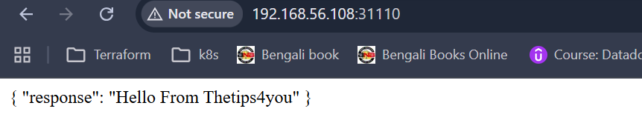
It is opening but it can change to loadbalancer only. And not use image which upload to docker hub

apiVersion: apps/v1
kind: Deployment
metadata:
name: nodeapp-deployment
labels:
app: nodeapp
spec:
replicas: 1
selector:
matchLabels:
app: nodeapp
template:
metadata:
labels:
app: nodeapp
spec:
containers:
- name: nodeserver
image: thetips4you/nodeapp:latest
ports:
- containerPort: 3000

---

apiVersion: v1
kind: Service
metadata:
name: nodeapp-service
spec:
selector:
app: nodeapp
type: LoadBalancer
ports:
- protocol: TCP
port: 5000
targetPort: 3000
nodePort: 31110

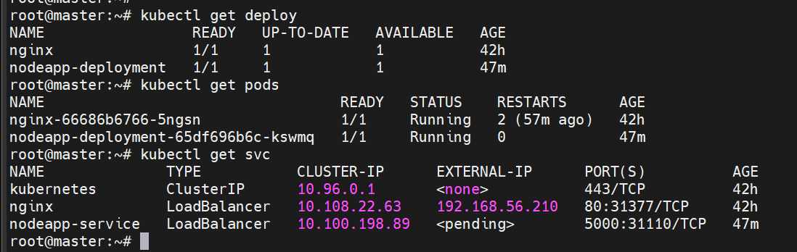

Change it To loadbalancer and image download form my docker hub:--
https://github.com/anupam02us/nodeapp_test/edit/master/deploymentservice.yml

apiVersion: apps/v1
kind: Deployment
metadata:
name: nodeapp-deployment
labels:
app: nodeapp
spec:
replicas: 1
selector:
matchLabels:
app: nodeapp
template:
metadata:
labels:
app: nodeapp
spec:
containers:
- name: nodeserver
image: anupam02us/nodeapp:latest
ports:
- containerPort: 3000

---

apiVersion: v1
kind: Service
metadata:
name: nodeapp-service
spec:
selector:
app: nodeapp
type: LoadBalancer
ports:
- protocol: TCP
port: 5000
targetPort: 3000
#nodePort: 31110

https://github.com/anupam02us/nodeapp_test/blob/master/deploymentservice.yml

not change loadbalancer, keep NodePort

apiVersion: apps/v1
kind: Deployment
metadata:
name: nodeapp-deployment
labels:
app: nodeapp
spec:
replicas: 1
selector:
matchLabels:
app: nodeapp
template:
metadata:
labels:
app: nodeapp
spec:
containers:
- name: nodeserver
image: thetips4you/nodeapp:latest
ports:
- containerPort: 3000

---

apiVersion: v1
kind: Service
metadata:
name: nodeapp-service
spec:
selector:
app: nodeapp
type: NodePort # change to nodport
ports:
- protocol: TCP
port: 5000
targetPort: 3000
nodePort: 31110

Worker node ip:31110

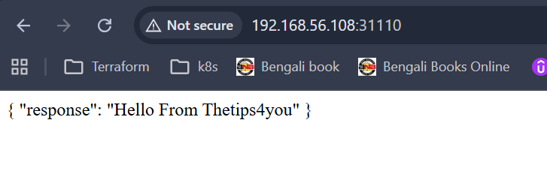

Finanl pipeline :--- I create one extra file in github, name “jenkinsfilefinal”

pipeline {
agent any

environment {
dockerimagename = "anupam2002us/nodeapp"
dockerImage = ""
}

stages {

stage('Checkout Source') {
steps {
git 'https://github.com/anupam02us/nodeapp_test.git'
}
}

stage('Build Image') {
steps {
script {
dockerImage = docker.build(dockerimagename)
}
}
}

stage('Pushing Image') {
steps {
script {
withDockerRegistry(
credentialsId: '8573e521-f729-4cd5-bb59-ccaa78e5a77f',
url: 'https://index.docker.io/v1/'
) {
dockerImage.push("latest")
}
}
}
}

stage('Deploying App to Kubernetes') {
steps {
withCredentials([file(credentialsId: 'kubernetes', variable: 'KUBECONFIG')]) {
sh '''
export KUBECONFIG=$KUBECONFIG
kubectl delete -f deploymentservice.yml
kubectl apply -f deploymentservice.yml
echo " deployed in Loadbalancer"
sleep 10
echo "deploy, pod, svc"
kubectl get deploy
kubectl get pods
kubectl get svc
'''
}
}
}
stage('Clean Workspace') {
steps {
sh '''
find "$WORKSPACE" -mindepth 1 -delete
'''
}
}

}
}

root@master:~# kubectl get deployment
NAME READY UP-TO-DATE AVAILABLE AGE
nginx 1/1 1 1 43h
nodeapp-deployment 1/1 1 1 10m
root@master:~# kubectl get pods
NAME READY STATUS RESTARTS AGE
nginx-66686b6766-5ngsn 1/1 Running 2 (139m ago) 43h
nodeapp-deployment-65df696b6c-5k84g 1/1 Running 0 10m
root@master:~# kubectl get svc
NAME TYPE CLUSTER-IP EXTERNAL-IP PORT(S) AGE
kubernetes ClusterIP 10.96.0.1 <none> 443/TCP 44h
nginx LoadBalancer 10.108.22.63 192.168.56.210 80:31377/TCP 43h
nodeapp-service NodePort 10.110.94.222 <none> 5000:31110/TCP 11m

